Guide for Critical Analysis Process - Formal Critique

The critical analysis process is an approach to critical thinking. (A way of thinking about things)
Use the following questions as a guide to informing your way of thinking about artworks.
Respond to as many of these as possible in formal paragraph form (under each title) to perform a thorough analysis of an artwork, the artist, and the context in which it was created.

Initial Reaction
Does this artwork remind you of anything?
What feelings do you have about this artwork?
What puzzles you about this artwork? What are your questions?
What questions would you ask the artist who made this artwork?

Description
What do you see? Can you identify the subject matter?
How was this artwork made?
What techniques were used?
What is the name of the artist? What do you know about him/her?

Analysis 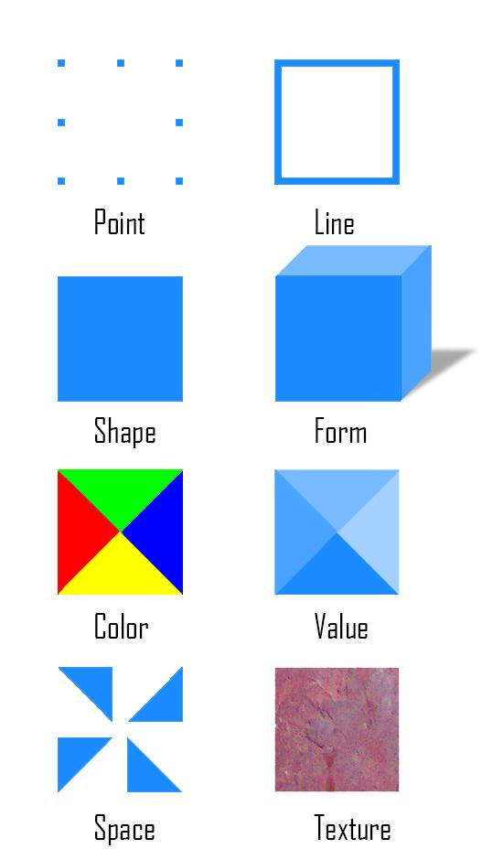
Which art elements are most important in this artwork? (Elements and Principles of Design)
Where is the focal point? How has this been emphasized?
Where are there areas of contrast or pattern?
Where or how has the artist suggested movement or created rhythm?
How has the feeling of balance been created?
Interpretation
What is happening in this artwork?
What makes the piece of art important?
How does the title of this artwork add to its meaning?
What feelings, thoughts or ideas does this artwork suggest to you?
Does this art connect with some aspect of your life?

Cultural Context
When was this piece made?
Where was this artwork made?
Why was the artwork created? How is it being used?
Was the artwork created for a particular individual or group? ----Who is the audience?
What connection might this artwork have with our present society or future society or culture?
Did the artist have a political or social reason for creating this artwork?

Informed Point of View
Do you feel this piece of art is successful? Why or why not?
What might you change about this work, and why?
What qualities make this artwork valuable?
How have your opinion and feelings changed from your initial reaction?
Does your artist fit the time period or style in which they worked or did they try to change and be different there, too?

***Add any questions and answers that help you look at your artist’s work.

